Chapter 3:-Introduction to Graphical Environment

Introduction To The Ubuntu Unity Desktop
This tutorial is supposed to guide the reader through some new features of the Unity desktop, Ubuntu's new desktop environment used since Ubuntu 11.04. The prime subject will be the launcher, which is something like a side-dock, and how to configure it the way it fits your likings most.

1 First Startup
If you have come in contact with any other operating system, be it an older version of Ubuntu, another distribution of Linux, Mac or Windows, you will be surprised about what the Unity desktop looks like at first glance. The first thing to notice is the dock-like structure on the left side of the screen.
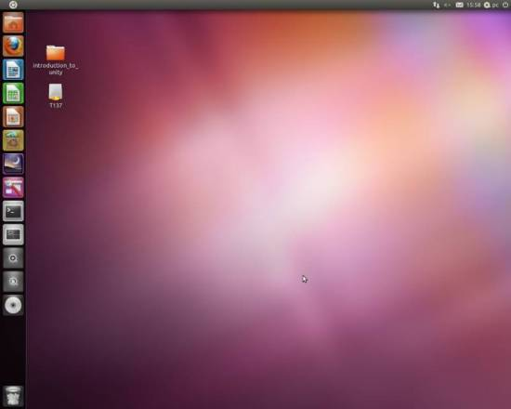

It is called launcher and is your main navigation tool on Unity. Having dealt with previous versions of Ubuntu or Microsoft Windows, after some browsing you will also notice that the multifunctional control button is missing, by which you normally could access everything there is on the computer, usually positioned in the bottom left corner of the screen. There is kind of a control button on the top left corner, however it does not open half the possibilities you had with its kind before. Some of the common options have been exported to the control panel.

2 The Launcher
The launcher propably is an easy-to-use execution dock for your most used applications. On first startup it contains some basic applications as Firefox, some LibreOffice Apps and links to the Files & Folders as well as the Applications section. To add items to the launcher, you can just drag and drop them there or, if you have the application to put there opened (minimized tabs will be available from the launcher, not the top panel), you can right-click its icon and tick the Keep in Launcher option.

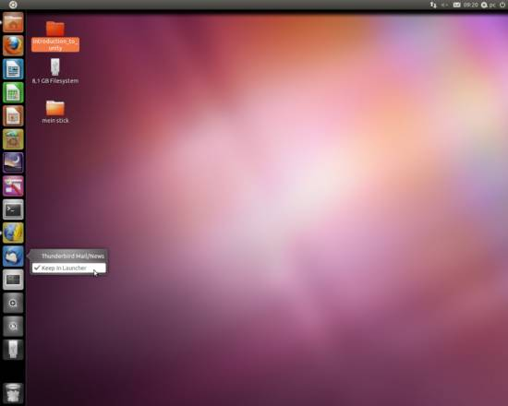

One of the launcher's main functions is its search bar that you can find in the main menu and in the Applications and Files & Folders sections. It is one of the quickest options to access a file if you do not have it fixed in your launcher. It behaves a bit strange however, compared to the search functions one is used to. It finds only those files that were opened at least one time and if you search for folders, it will only give you its contents (if one of the contained files was opened once, otherwise it will not find anything).
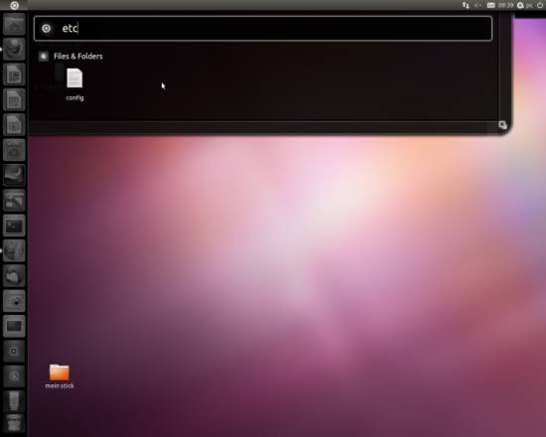

Another way to access your files quickly is by right-clicking the application section for applications and browsing the home directory or every folders top bar for folders. Right-clicking on Applications will give you the classic option to browse through the different categories of applications, although they are not displayed as compact as before. Clicking on the monitor icon on the top bar of any folder window will direct you to the root directory of your system.

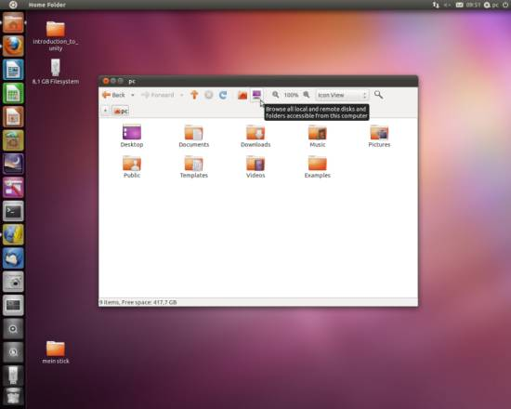
3 Configuring the Launcher + Unity
If you have already been to the system settings to try to modify the launcher, you will have noticed that there is not much to be modified yet.

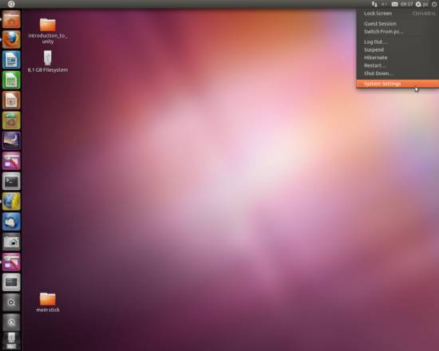

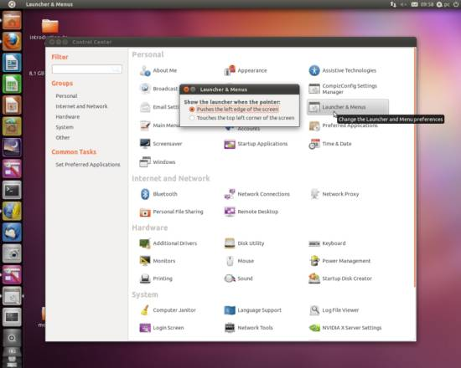
You can however install Compiz Fusion as well as its CompizConfig Settings Manager with your Ubuntu Software Center, which has a plugin to slightly modify the launcher. It is located in System Settings > Personal > CompizConfig Settings Manager > Desktop > Ubuntu Unity Plugin.

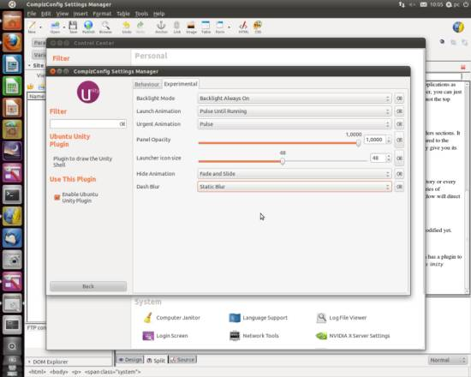

You may find yourself keeping a great deal of applications and files in your launcher since they are quite circumstantial to access on Ubuntu 11.04 that's why it might be a good idea to configure the icon size within the launcher to be smaller. If your opinion is that Unity is too hard to handle, you can still try to make life easier by configuring your own hotkeys via System Settings > Keyboard Shortcuts (there are already some installed, but they do not help to handle Unity in a great manner) or accessing files via Terminal (after you have got yourself a new layout, so it does not have a purple background any longer).
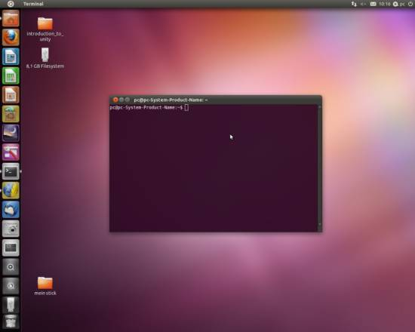

Schedule Tasks Using Gnome-schedule (A cron & at GUI) in Ubuntu
Gnome-schedule features
-- If run as root you can edit any users ‘crontab' and ‘at' tasks.
-- A parser that translates ‘crontab' entries into human readable strings like ‘Every hour' and not ‘0 * * * *' which might seem confusing to some.
-- An applet where you from an dropdown menu can choose to add a task, manage tasks and get help.
-- You can choose to use advanced mode which will display the tasks in a different way, where you can see the ‘crontab' entries like you are used t
-- As mentioned you can set a title and an icon for tasks.
-- Create templates like ‘Virus check' or ‘Compile kernel'.
-- Predefined common expressions like: every minute, every week, tomorrow, next week.
-- You may use an calendar to browse for the day you want a task executed.
Install Gnome-schedule Ubuntu
sudo apt-get install gnome-schedule
This will complete the installation.
Using Gnome-schedule
If you want to open this application Go to Applications--->System tools--->Schedule
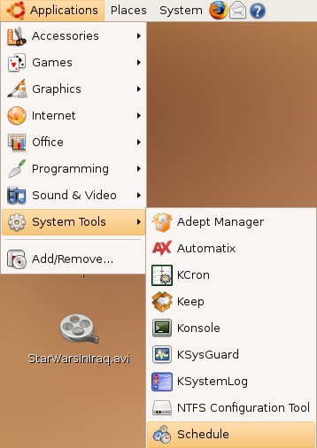

Once it open you should see the following screen

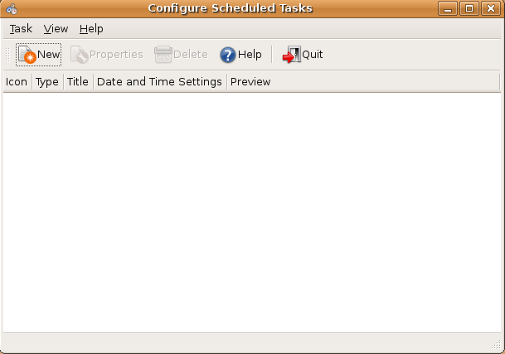
If you want to schedule new task you need to click on new tab Now you need to select one option displayed on the screen and click ok
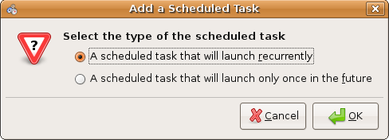

If you want to schedule task using Basic view enter all the fields and click ok

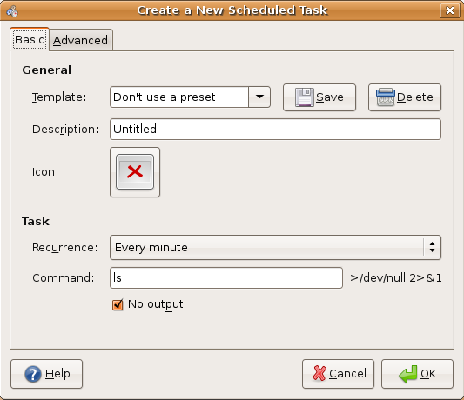

If you want to schedule task using Advanced view enter all the fields and click ok
